MASTER WEBSITE COPYWRITING
- Project: Personal engineering & Entrepreneurship portfolio website
- Target Audience: US/UK University admissions officers, engineering faculty, scholarship committees
- Core Theme/ Spike: Hardware prototyping + Commercial viability + Community leadership
- Design Style: Clean, modern tech-minimalist (Dark/Light mode toggle, grid-based layout, subtle blueprint/circuit accents)

0. GLOBAL NAVIGATION BAR (HEADER)
- [DEV / UI INSTRUCTION]: Sticky top navigation bar with blur backdrop. Right-aligned CTA button highlighted in accent color.
- [STATIC COPY]:
  - Logo / Brand Name (Left): [YOUR FULL NAME]
  - Menu Links (Center): About | Engineering Projects | Venture & Leadership | Broadcasting | Credentials
  - Primary CTA Button (Right): Download CV (PDF) (Links to final Resume PDF)

1. HERO SECTION (ABOVE THE FOLD)
- [DEV / UI INSTRUCTION]: 2-column split layout on desktop (60% Left: Typography & CTAs; 40% Right: Visual Media). Below the split, include a full-width horizontal "Key Metrics Ticker/Bar" with 5 stat cards.

1.1. Hero Text & CTAs (Left Column)
- [STATIC COPY - Main Headline (H1)]: Hi, I’m [Your Full Name].
- [USER INPUT NEEDED - Sub-headline / Personal Tagline]:
  - Viết đoạn ngắn:
    - Câu 1: Định vị bản thân bằng 3 vai trò chính (Ví dụ: An Embedded Systems Maker, Tech Entrepreneur, and Community Leader based between Northampton, UK and Hanoi, Vietnam)

    - Câu 2: Điểm chung lớn nhất giữa các mạch điện bạn hàn và các dự án em khởi xướng là gì? Em muốn dùng kỹ thuật Điện - Điện tử để giải quyết vấn đề thực tế nào?
- [STATIC COPY - CTA Buttons]:
  - Button 1 (Solid): Explore Engineering Projects ↓ (Smooth scroll to Section 3)
  - Button 2 (Outline): Get in Touch (Smooth scroll to Footer)

1.2. Hero Visual (Right Column)
- [DEV / UI INSTRUCTION]: High-resolution portrait frame or interactive media card.
- Media Asset Needed from User: 1 ảnh chụp đang thao tác với mạch điện hoặc ảnh thuyết trình về ngành/kinh doanh

1.3. Quick Metrics Bar (Bottom of Hero)
- [DEV / UI INSTRUCTION]: 5-column responsive grid showing verifiable highlights.
- [STATIC COPY]:
  - A*A*A*A*: Predicted A-Levels (Maths, Further Maths, CS, Physics)
  - 1540 SAT: 790 Math, 750 RW | 8.0 IELTS
  - Gold Medal: 50th INOVA Int'l Invention Show (2026)
  - 1st Prize: CATS UK Business Incubator (2026)
  - Full-Tuition: Frank Dickens Scholar @ Bosworth UK

2. ABOUT ME SECTION (PERSONAL NARRATIVE)
- [DEV / UI INSTRUCTION]: Asymmetric layout. Left side: 3-photo bento grid/collage + Quick Facts box. Right side: 3-paragraph narrative text.
- [STATIC COPY - Section Header]:
  - Eyebrow: 01 / MY STORY
  - Heading (H2): Bridging the Lab Bench and the Real World

2.1. Personal Narrative (Right Column)
- [USER INPUT NEEDED - 3-Paragraph Story (Khoảng 200 - 250 từ)]:
  - Paragraph 1: The Engineering Spark:
    - Hành trình từ THPT Chuyên ĐH Sư Phạm sang Bosworth Independent School (UK) đã nuôi dưỡng niềm đam mê Toán và Vật lý thế nào? Khoảnh khắc nào khi tự đọc sách mạch điện của Giorgio Rizzoni hay khi làm các dự án điện tử khiến em nhận ra mình muốn theo đuổi ngành EEE?
Maths and Physics have always been my favourite subjects since I studied in Vietnam. That was also when I started loving engineering. In Vietnam, I was infused with the world of theoretical physics; whereas, in the UK, I had an opportunity to apply the knowledge into real-life products and research papers.
The spark for Electrical and Electronic Engineering was lit when I was watching a video about the blue LED and how it changed the whole world. I was amazed at such a big impact from an object whose size is less than a human hand.

  - Paragraph 2: The Entrepreneurial Mindset:
    - Tại sao luôn muốn biến kỹ thuật thành sản phẩm ứng dụng (như làm hệ thống sưởi cho ký túc xá Bosworth hay đem sản phẩm phần cứng đi thi khởi nghiệp)? Theo em, yếu tố thương mại và trải nghiệm người dùng đóng vai trò gì trong kỹ thuật?
For me, engineering is a bridge between theory and practice. Theory will be useless if it cannot be applied to human life in any form. The main purpose of research is still human life. Therefore, user experience must be one of the top priorities when designing a new product.
  - Paragraph 3: Beyond the Breadboard:
    - Ngoài giờ làm các công việc liên quan đến kỹ thuật, em là người như thế nào trên sân cỏ, trong khu nội trú Delapré House hay trước ống kính livestream bóng đá hay bất cứ điều gì khác? Tư duy phân tích chiến thuật bóng đá và tổ chức giải đấu có bổ trợ gì cho tư duy hệ thống của một kỹ sư không?
Leaving the circuits and wires, I still connect, but instead of electricity, I connect humans.
On the sports field, I am a midfielder connecting the defensive players and attackers.
In the boarding house, I am a catalyst who came up with new ideas to get boarders involved.
In front of the camera, I was a streamer connecting emotions with viewers.

2.2. Visual Assets (Left Column)
- [DEV / UI INSTRUCTION]: Bento grid of 3 images with hover captions:
  - Image 1: Tại trường Bosworth Independent School.
  - Image 2: Cận cảnh bàn làm việc với với các dự án hoặc các quyển sách về ngành
  - Image 3: Hoạt động thể thao hoặc làm Host chương trình.

3. SIGNATURE ENGINEERING PROJECTS & RESEARCH
- [DEV / UI INSTRUCTION]: Display as expandable Case Study Cards or full-width alternating feature blocks. Each project MUST contain: (1) Tech Stack Tags, (2) Verified Facts from CV, (3) Expandable/Tabbed "Behind the Scenes: Engineering Log", and (4) Media Gallery/Video Embed.
- [STATIC COPY - Section Header]:
  - Eyebrow: 02 / HARDWARE, SOFTWARE & RESEARCH
  - Heading (H2): Engineering Projects & Scientific Investigation

PROJECT CARD 1: EVCharge AI: Solar-Powered Smart EV Charging Station
- [STATIC COPY]:
  - Award Badge: Gold Medal: 50th International Invention Show (INOVA 2026)
  - Role: Embedded Systems Developer | Timeline: Jul 2026 - Sept 2026
  - Tech Stack Tags: ESP32 Arduino Thermal/Humidity/Flame Sensors Solar Integration AI Load Allocation
  - Core Overview:
    - Built a smart electric vehicle charging prototype powered by solar energy to shave peak grid loads and optimize charging completion.
    - Programmed and assembled hardware protection circuits using ESP32 and Arduino microcontrollers integrated with thermal, humidity, and flame sensors to prevent charger overheating and fire hazards.
    - Implemented AI algorithms to forecast grid demand and dynamically allocate shared power caps.
- Step 1: Researching:
When I was researching to find an idea for the project, I read an article discussing the risks to electricity infrastructure.
The article stated that Vietnam has 374,816 EVs (electric vehicles) up to May 2026: 369,849 electric passenger cars, 3,396 electric trucks, and 1,571 electric buses. This number is projected to be 1 million electric vehicles (not motorbikes) by 2030.
However, in dense urban areas, where many people have electric vehicles, the demand is so high that if 100,000 vehicles were using 60–120 kW fast chargers at the same time, this could create an instantaneous load of 6–12 GW, which is a significant fraction of the national peak. The author worried that such concentrated demand, rather than the total energy consumed, puts pressure on local grid infrastructure and risks overloading specific distribution nodes.
https://dtinews.dantri.com.vn/vietnam-today/electric-vehicle-surge-raises-risk-of-local-grid-overload-20260410083533437.htm

After reading, I believe that this will be a huge problem in the future, and there is an urgent need for a smart charging system that can intelligently manage how power is allocated across vehicles.

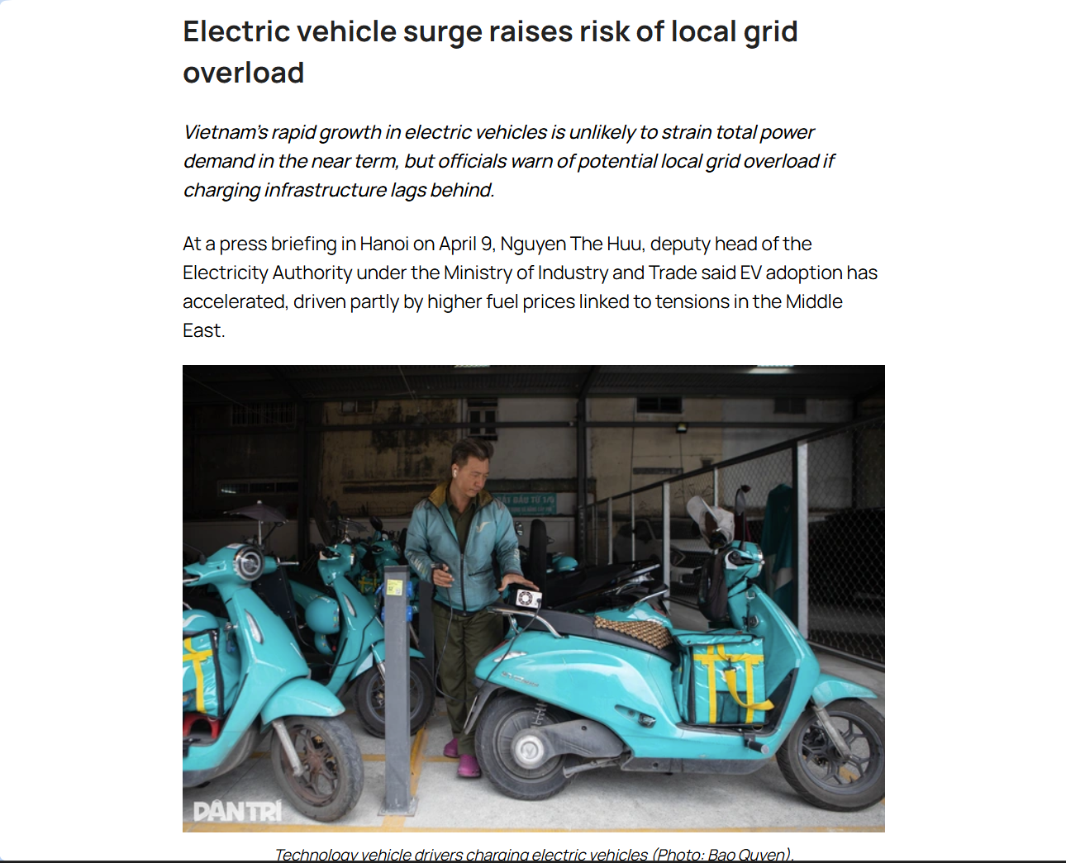

- Step 2: Discuss ideas with teams, choose a final idea, and make a plan.
After discussions with my mentor and my team, there were some potential ideas about robot hands or smart glasses, so we decided to go with my idea: A smart charging system.

The project aims to create a sustainable and safe charging station powered by solar energy.
The system would be like this:

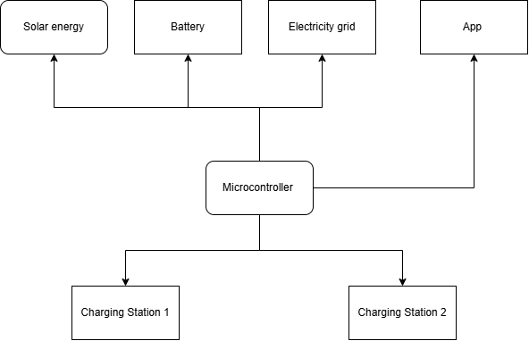
Our objectives for the system are:
- Design two demo charging stations capable of measuring voltage, current, power, temperature, and battery status in real time.
- Develop an energy management system that can automatically adjust the power output of each charging station when the total available power is limited.
- Develop a user application and an administrative app dashboard to monitor charging sessions, set target battery levels, specify required vehicle departure times, and view charging history.
- Integrate grid electricity, simulated solar energy, and battery storage to investigate flexible energy management strategies.
- Compare intelligent charging algorithms with conventional approaches, such as equal power distribution and first-come, first-served prioritisation.

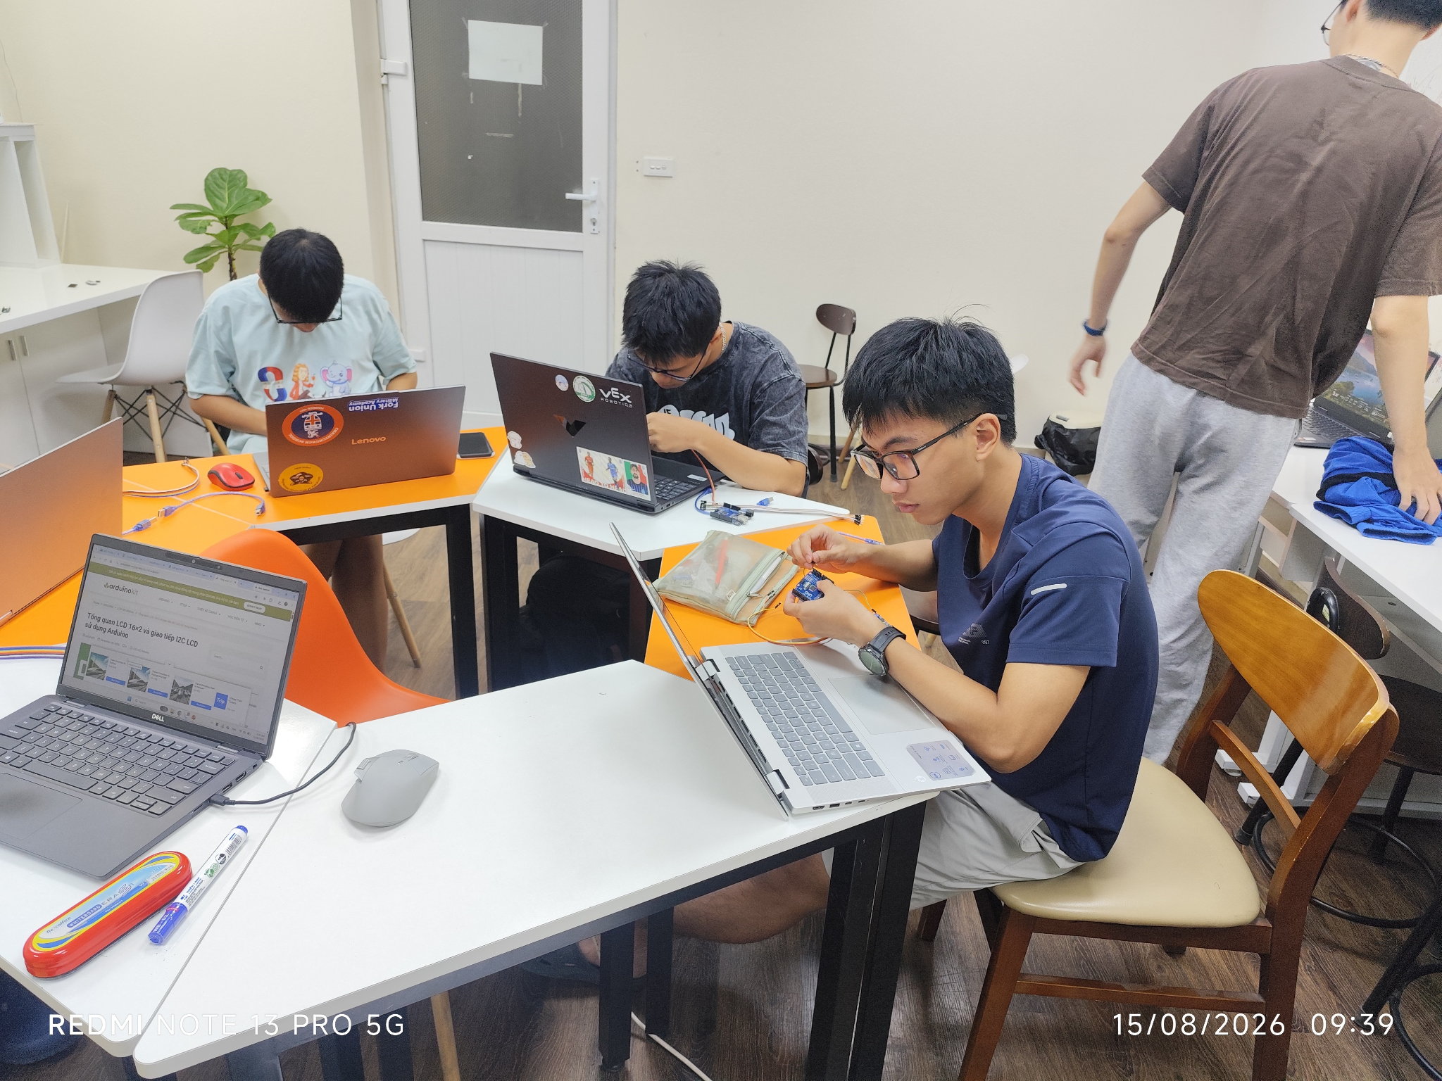

- Step 3: Individual work
My task was to program and assemble hardware protection circuits using ESP32 and Arduino microcontrollers integrated with thermal, humidity, and flame sensors to prevent charger overheating and fire hazards. I mostly used Arduino IDE for this task.
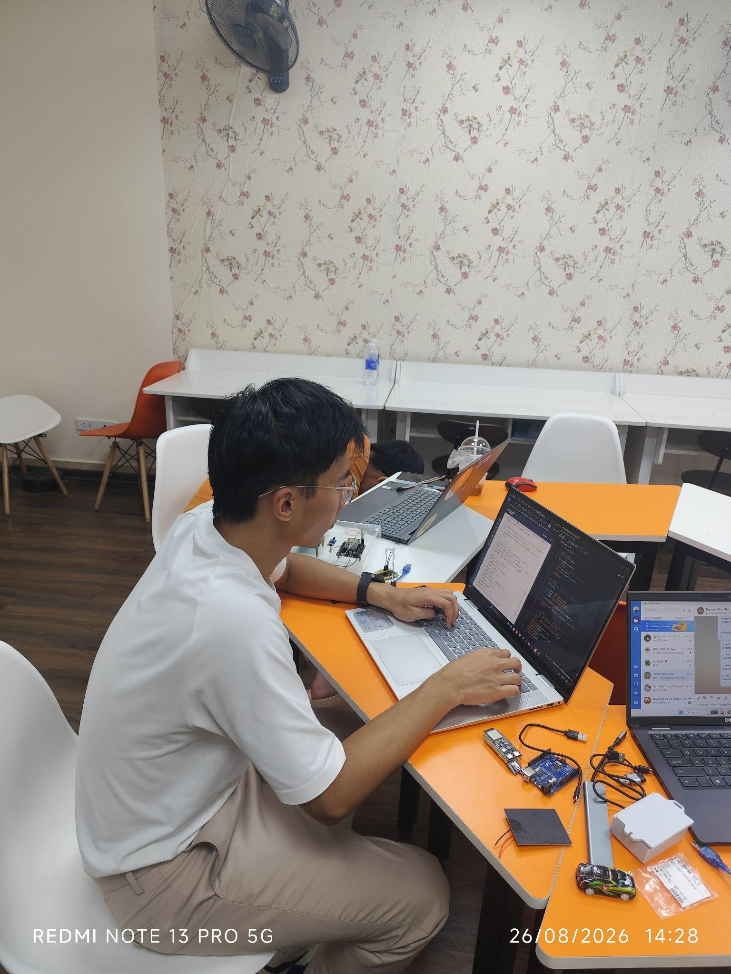
- Step 4: Testing and Evaluation.
After everyone finished the work, we needed to test and evaluate our products. We tested it by giving different scenarios to make sure the system functioned properly.
For example, we tested the system with both cars in the slots and witnessed how the system distributed energy and showed it in the app for users.
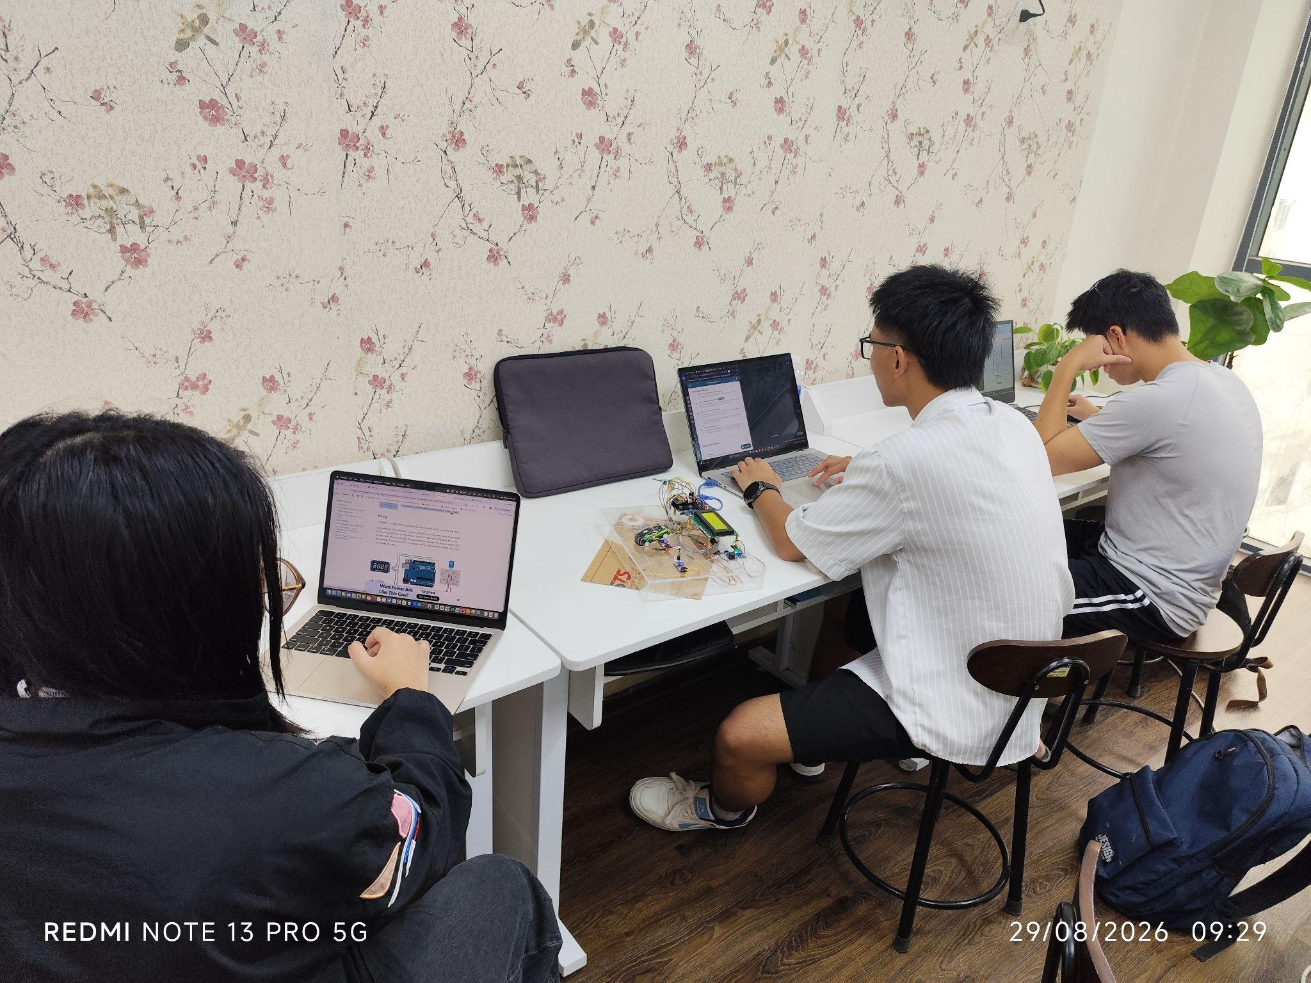

- [USER INPUT NEEDED - Engineering Behind-the-Scenes (2-3 câu)]:
  - Thách thức kỹ thuật lớn nhất khi tích hợp các cảm biến nhiệt, độ ẩm, lửa vào mạch bảo vệ ESP32/Arduino là gì? Hệ thống ngắt mạch bảo vệ và thuật toán phân bổ công suất phối hợp với nhau như thế nào khi có nguy cơ quá tải?
The most challenging part of integrating the sensors was ensuring that all the components worked together as a cohesive system rather than as independent units. I had to consider different scenarios. What will happen if the fire sensors detect fire? How should the system react when the temperature is too high?
Answering these questions forced me to connect the components carefully, ensuring that each component not only functioned independently but also contributed effectively to the overall system.
- [DEV / UI INSTRUCTION - Media Slot 1]:
  - Embed 1 Video Demo (MP4/YouTube) quay cảnh mạch hoạt động & cảm biến phản ứng với nhiệt/lửa + 1 ảnh chụp Huy chương Vàng INOVA 2026 + 1 ảnh sơ đồ khối hệ thống.

PROJECT CARD 2: Smart Heater Control System (Campus IoT)
- [STATIC COPY]:
  - Role: Independent Project Lead & Systems Developer | Organization: Bosworth Independent School
  - Timeline: Oct 2026 - Present
  - Tech Stack Tags: Arduino ESP32 LoRa Modules Python JavaScript HTML/CSS
  - Core Overview:
    - Designed and assembled a hardware control system using Arduino, ESP32, and LoRa Modules.
    - Developed a functional web application using Python, JavaScript, CSS, and HTML enabling house parents to turn heaters on and off remotely and allowing students to submit heating requests.
Steps:
- Step 1: Define the scope and the problem area
As a Boarding Leader, my responsibility was to raise ideas to improve students’ boarding experiences. After hearing one of my friend complaining about the heaters when there were days he felt cold and wanted to turn on my heater, but he cannot turn on the heater by himself without permission in the main building. This inconvenience inspired me to develop a more efficient control system that could simplify the process and automate the heater's operation based on environmental conditions, reducing reliance on humans.
- Step 2: Planning
To embark on a major project like the Smart Heaters Controlled System, I need to understand how the system will work. Therefore, I sketched my system flowchart.
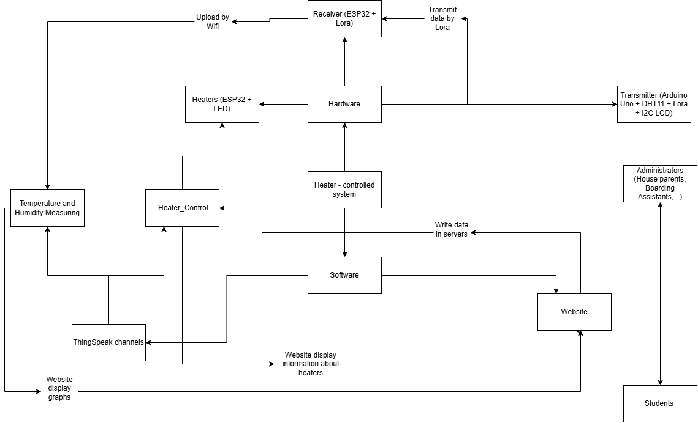
After ensuring the system is designed correctly, I started working on each part - building modules and building website.
- Step 3: Vibe-coded the website application.
Having experiences from the Library System Project, I decided to make a website for students to make requests of turning on the heaters and administrators will accept or reject the requests.
I used Visual Studio Code AI to vibe code. During the process, sometimes I still needed to debug by hand and read the code.
(Ảnh minh họa): ER Diagram of the database.
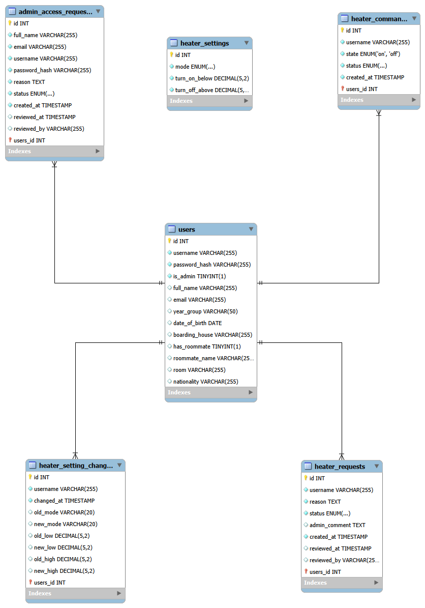
Thêm ảnh ngồi code.
- Step 4: Programmed sensors and microcontrollers (Lora modules).
At the same time, I also programmed sensors and microcontrollers.
This task is more difficult in depth and breadth than any project I have ever done; therefore, I needed to research and try a lot before completing it.
For sensors, I used a DHT11. For screens, I used an I2C-LCD 16x2. I also used three microcontrollers: 2 ESP32 DevKit V1 and 1 Arduino Uno. Besides, I also integrated LoRa modules for transmitting data.
Because there was few guidelines on how to make a similar project, I needed to draw my own circuit in Fritzing, which was the first time I using the app, taking me much time to use.
(Ảnh working with sensors)

- Step 5: Testing and Evaluation:
After finishing building the website and the hardwares, I tested my product. Given that my transmitter was in another boarding house (which was about 0.8 km distance), I tested whether two modes - manual & automatic - would work properly or not.
(2 clips ạ)
- [USER INPUT NEEDED - Engineering Behind-the-Scenes (2–3 câu)]:
  - Vấn đề thực tế nào trong khu nội trú tại Bosworth đã thôi thúc bạn làm dự án này? Tại sao chọn giao thức truyền dẫn LoRa kết hợp ESP32/Arduino cho tòa nhà nội trú, và quá trình kết nối giữa phần cứng với Web App diễn ra như thế nào?
The main reason I chose LoRa modules was because of the school Wifi. My school’s WiFi required signing in to connect, which was a barrier for my project. Therefore, I needed to connect the microcontrollers using a different wave, and LoRa was the choice. I still needed Wifi, but only for one main microcontroller that received signals from sensors.
- [DEV / UI INSTRUCTION - Media Slot 2]:
  - Carousel gồm: (1) Ảnh chụp bo mạch Arduino/ESP32 gắn module LoRa, (2) Ảnh chụp màn hình giao diện Web App của House Parents và giao diện Request của Students, (3) Video ngắn quay cảnh bấm nút trên web làm đóng/ngắt mạch thực tế.

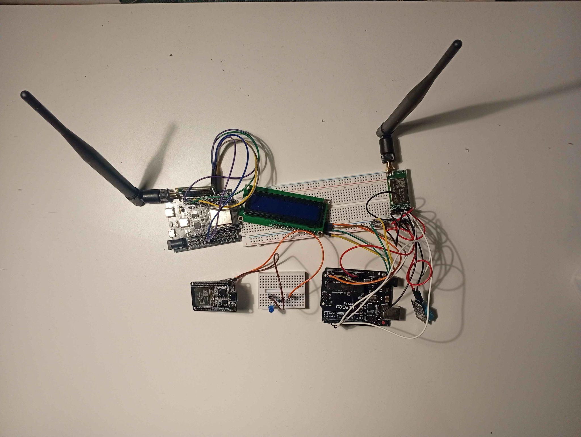
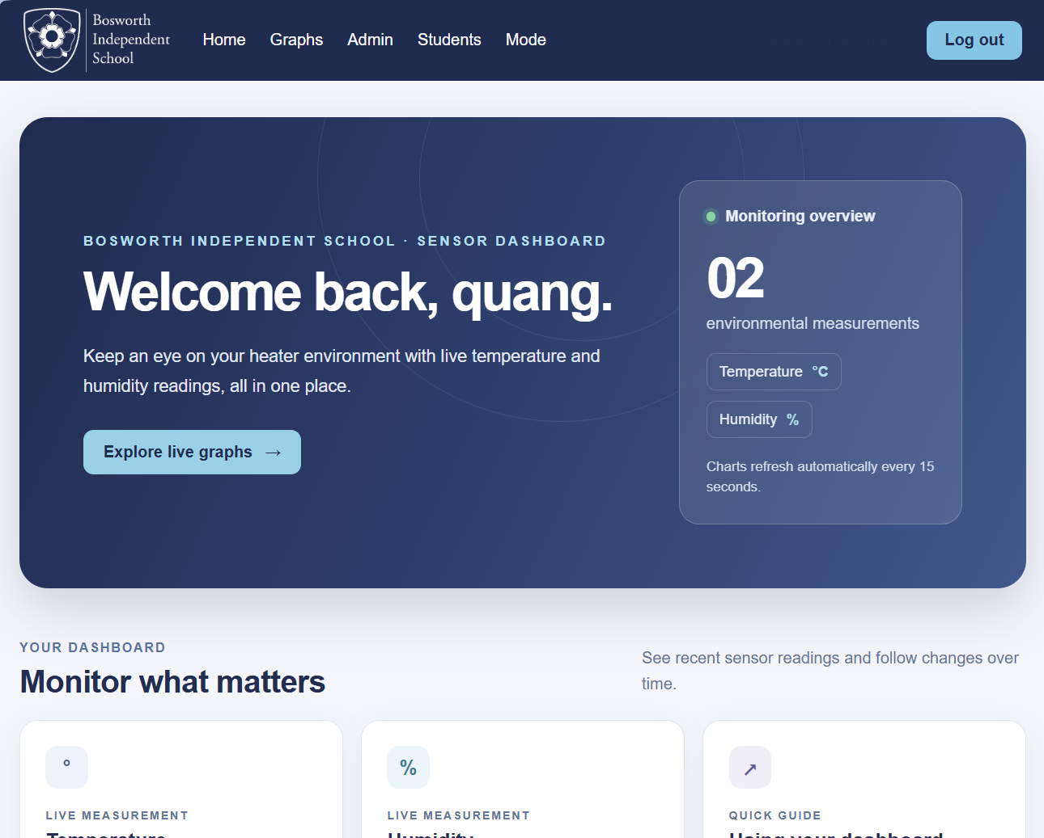
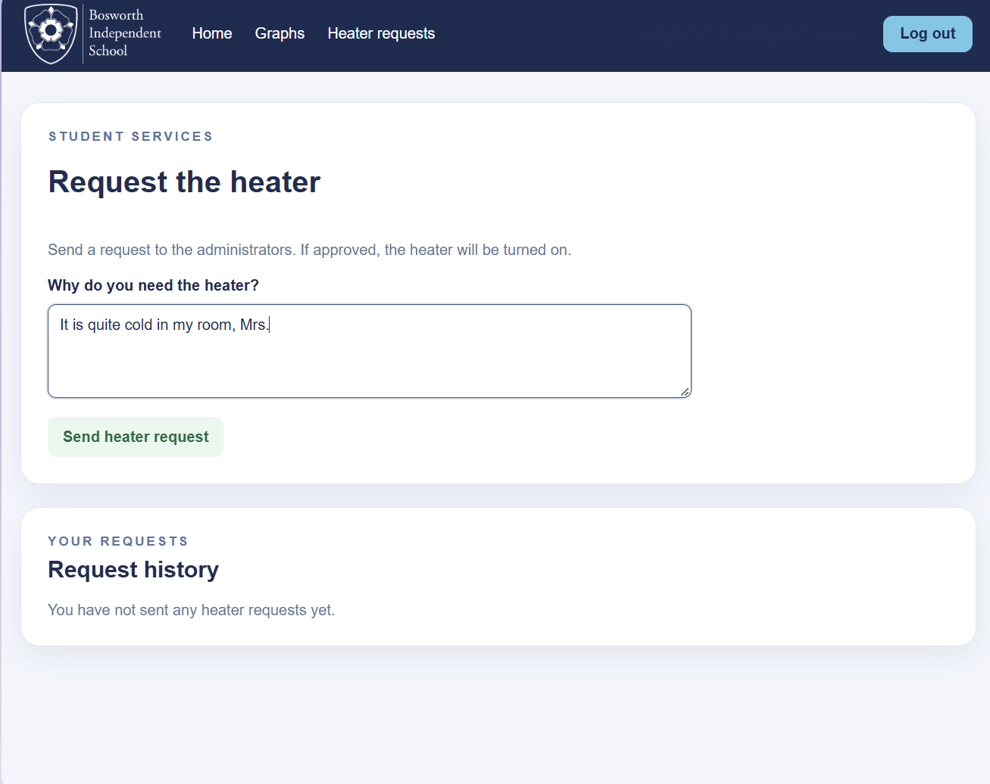

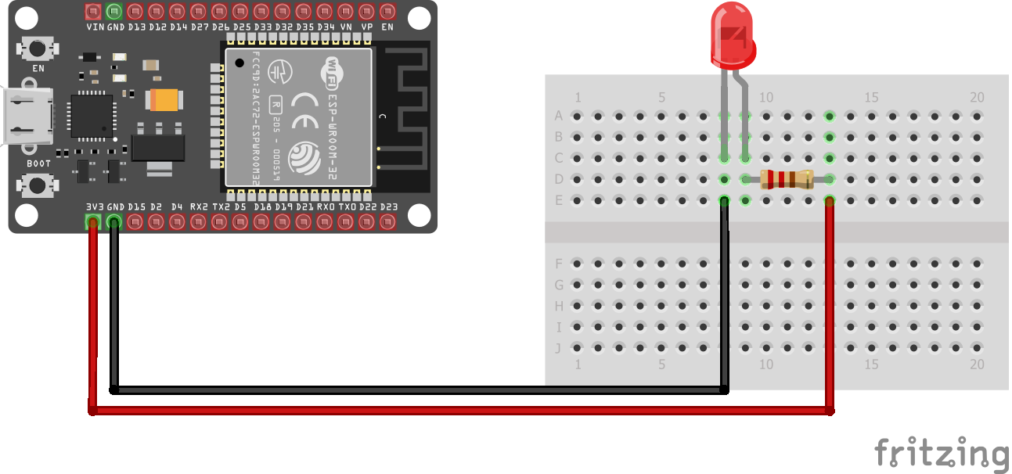(Heaters)

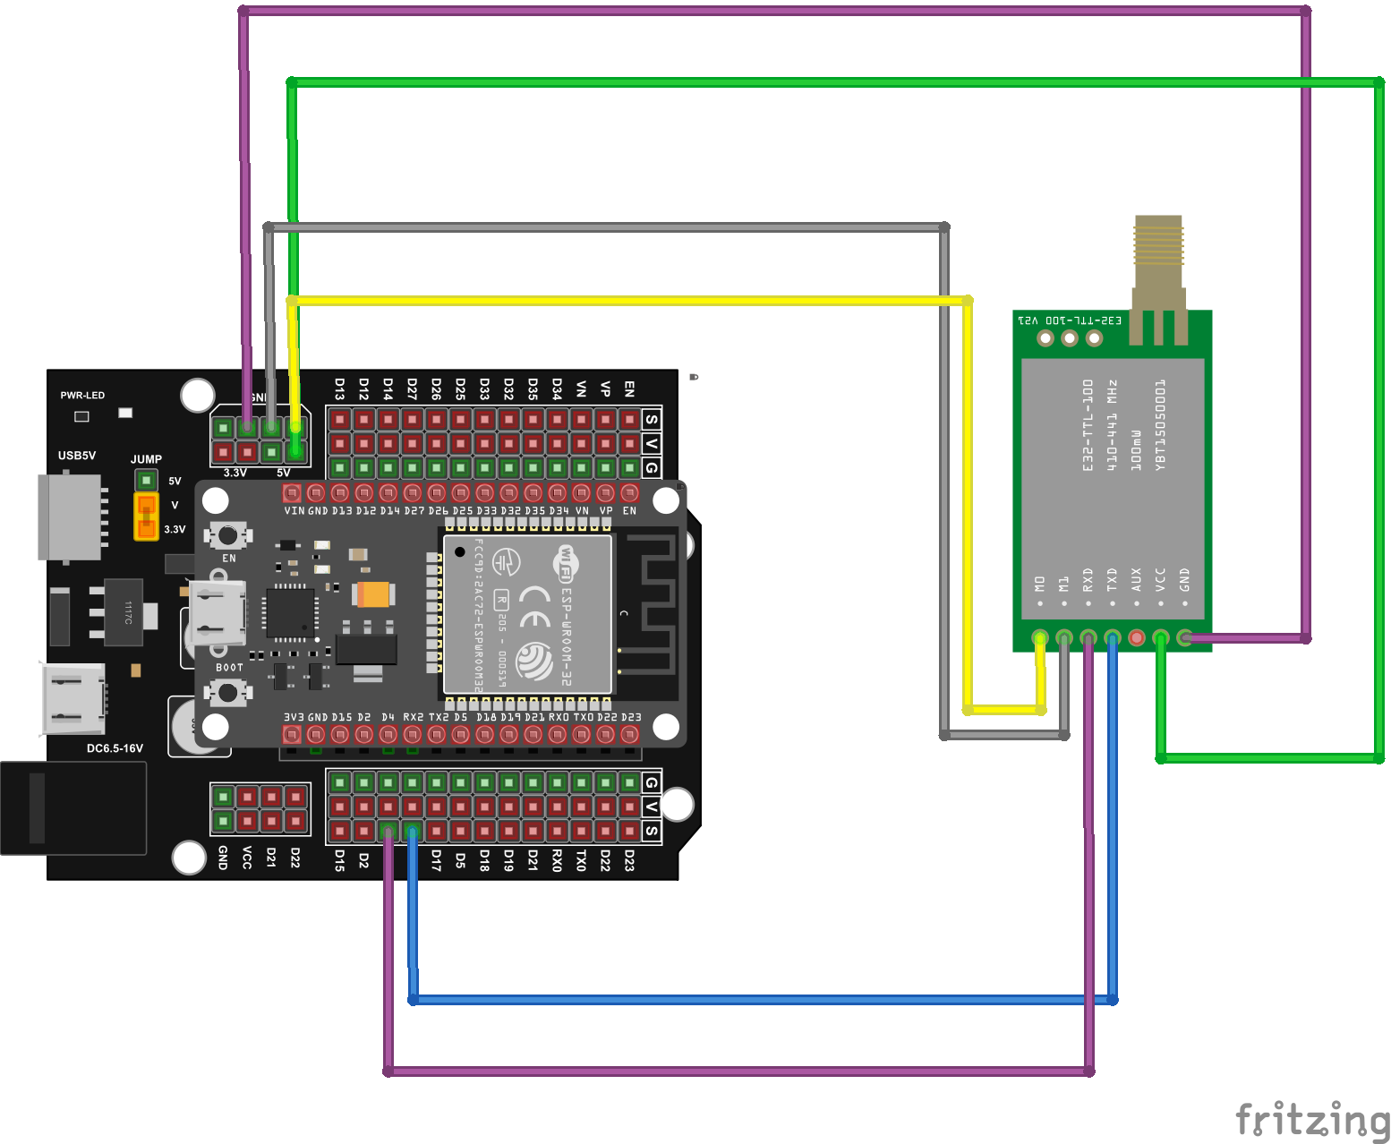
(Receiver)

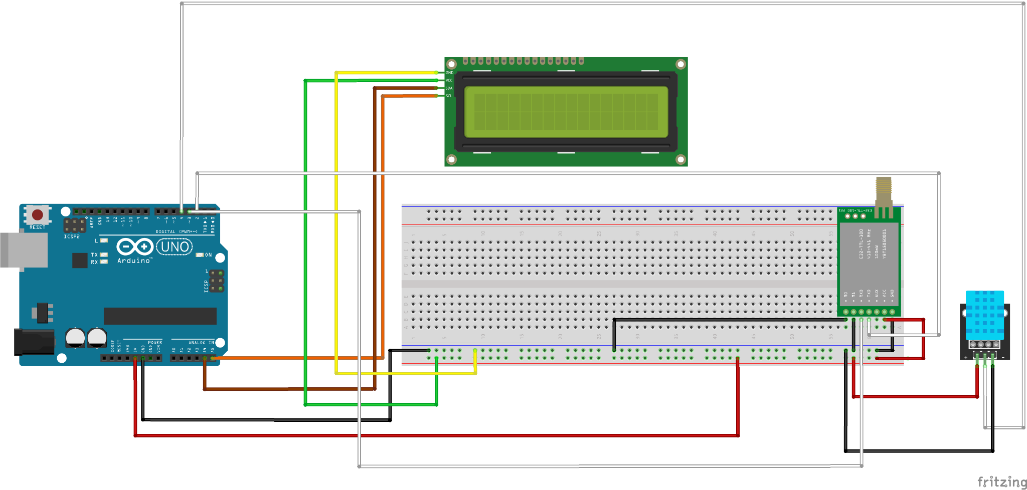
(Transmitter)

PROJECT CARD 3: Extended Project Qualification (EPQ): Solid-State vs. Incandescent Lighting
- [STATIC COPY]:
  - Grade Badge: Grade Achieved: A (49/54)
  - Role: Independent Researcher | Organization: Bosworth Independent School | Timeline: Sep 2025 - Mar 2026
  - Dissertation Title: “To what extent does LED lighting offer superior technical performance compared to incandescent lighting in terms of efficiency, colour rendering, and reliability?”
  - Core Overview:
    - Authored and defended a 6,000-word independent technical dissertation evaluating luminous efficacy, spectral colour rendering, and component reliability.
    - Presented findings at the school science fair, proposing an optimized classroom lighting solution to enhance student concentration.
The project aims to make an overall comparison between efficiency, colour rendering and reliability of LEDs and incandescent light bulbs, making the fundamentals for further research focus on improving both the efficiency and colour quality of LEDs.

- [USER INPUT NEEDED - Research Takeaways:
  - Phát hiện thú vị nhất sau khi viết 6.000 từ về hiệu suất quang thông và độ hoàn màu của đèn LED là gì? Giải pháp ánh sáng lớp học đề xuất tại hội chợ khoa học của trường giúp cải thiện sự tập trung của học sinh bằng cơ chế nào?
One of the most fascinating and surprising insights is actually not in the report: Psychology of Light. Human eyes take yellowish light as relaxing and restful, whereas white light is considered productive and work-oriented. That fact led me to propose the idea of changing all the light bulbs in tables in boarding rooms to LEDs for students to study, and in the ceiling to yellow for relaxation.
- [DEV / UI INSTRUCTION - Media Slot 3]:
  - 1 ảnh chụp thuyết trình tại Science Fair của trường Bosworth + Nút bấm View 6,000-Word Dissertation (PDF).

PROJECT CARD 4: Digital Library Management System
- [STATIC COPY]:
  - Role: Project Initiator & Developer | Organization: Bosworth Independent School
  - Timeline: May 2026 - Present
  - Tech Stack Tags: Python SQL JavaScript HTML Relational Database
  - Core Overview:
    - Designed and implemented a relational database architecture for book inventory and user authentication.
    - Co-programmed a functional web application using Python, JavaScript, and HTML enabling students to search catalogs, borrow, and return books.
    - Collaborated with the Student Council Environment Committee to digitize records and manually migrate library data.
The project aims to digitize the library, making the borrowing, returning, and searching for books processes more convenient and attracting more students to use the library as a quiet place for studying and reading.

It starts with a request from one member in my school house - Bobby. He wanted to have a quiet place to sleep and do work during lunchtime. We had a library, but it was messy, and the borrowing and returning processes were outdated. Receiving the comment from my member made me think of a way to improve the library and make it work.

Steps:
- Step 1: Define goals and aims:
It started with my observation that students in Bosworth lacked a space to read and study during breaks and lunchtime. There was a small and cozy library in the hall; however, it was used as a storage room during summer and hadn’t been cleaned yet. Also, the borrowing and returning books process was outdated, as the data was only written down in the notebooks, making it difficult to track due dates or borrowers.

Acknowledging of those potentials and works need to be done, I and my friends in the Environment Commitee refurbished the library, and also created a Bosworth Library System with the aim to provide a quiet space for students in Bosworth, and make the borrowing and returning processes more organized and digital.

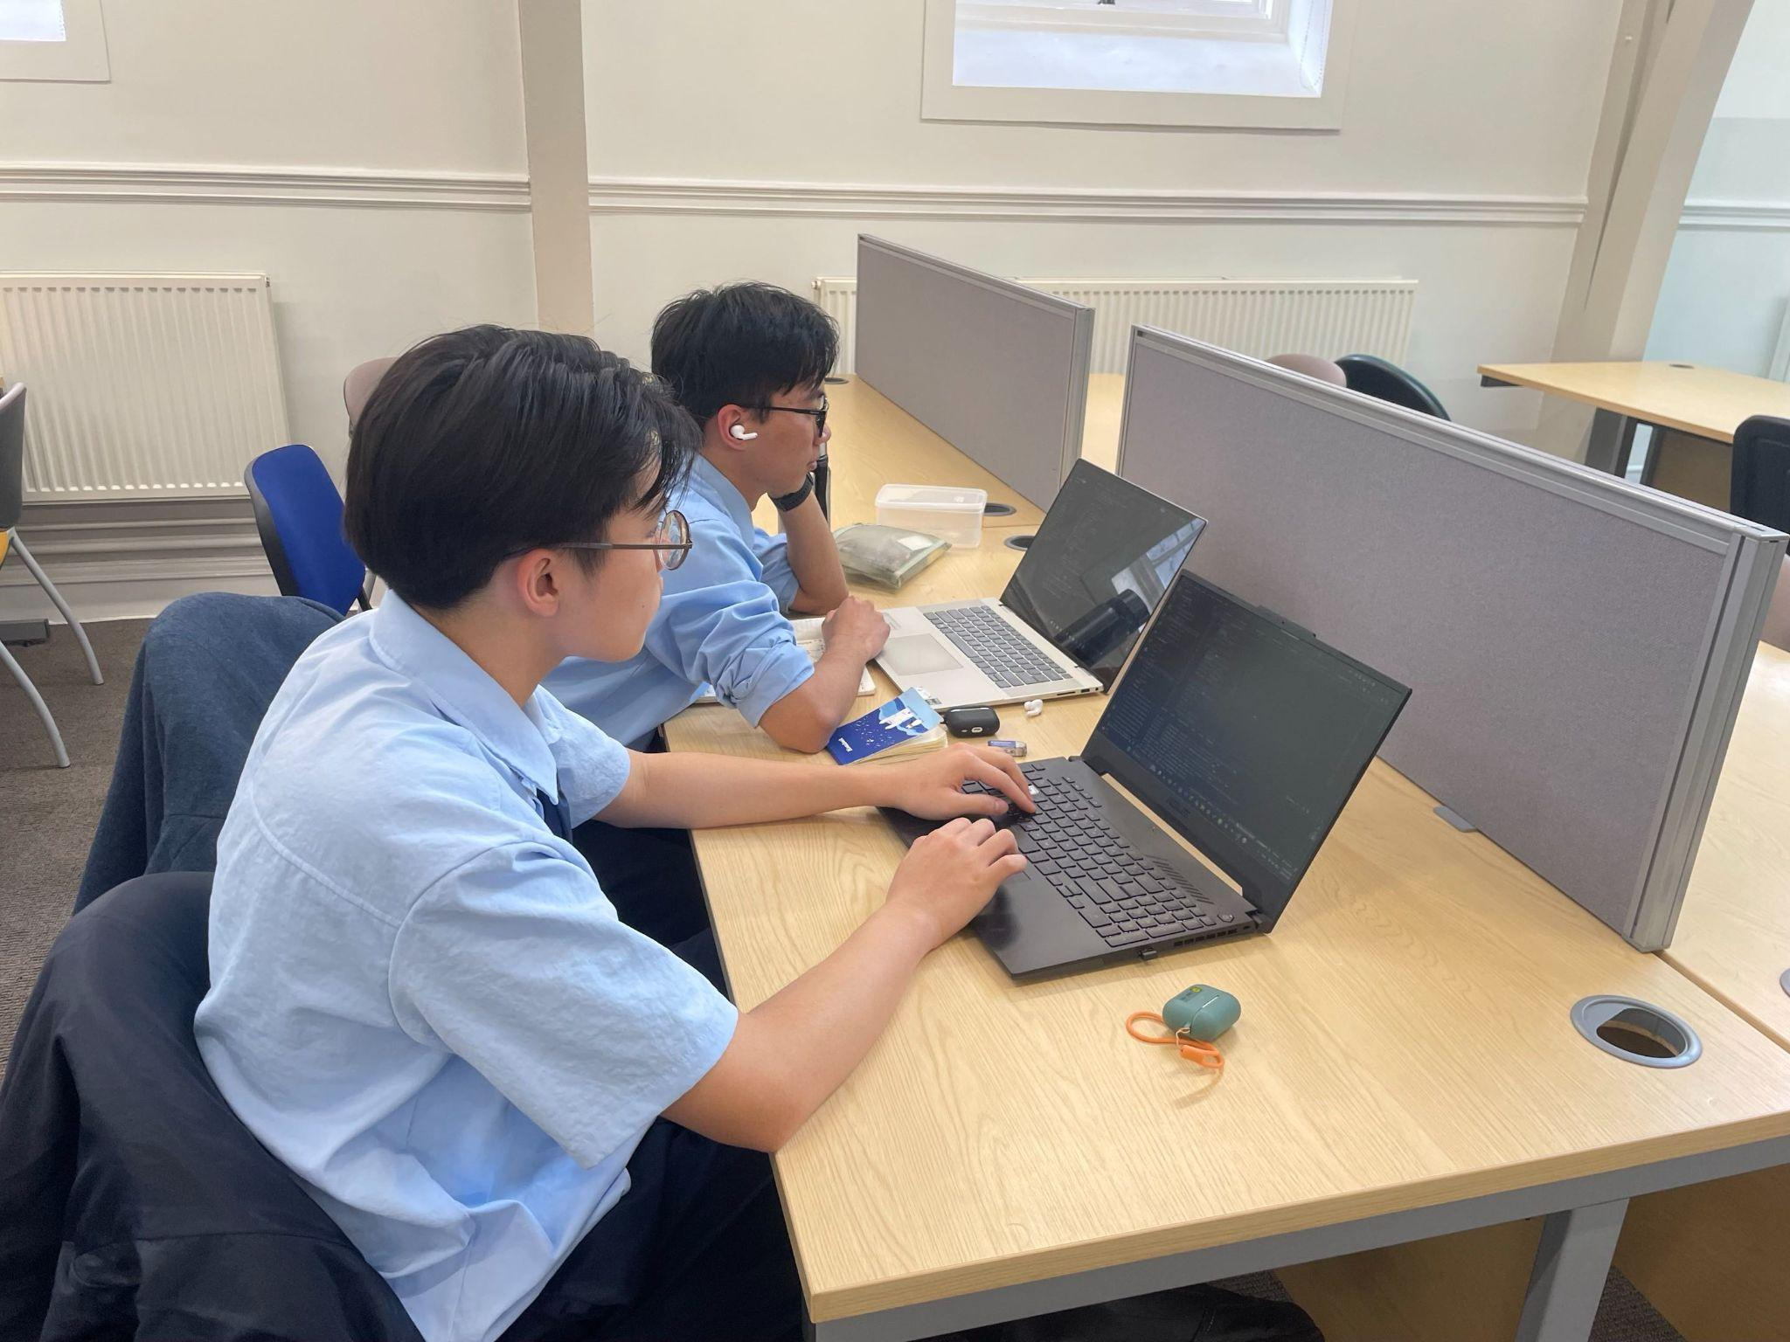

Step 2: Build the database
As I am in charge of building the database, I need to collect data on which books were in the library. My friends and I had to scan the ISBN code of every book and put it into the sheet.
At the same time, I was self-learning SQL through a video SQL Tutorial - Full Database Course for Beginner (SQL Tutorial - Full Database Course for Beginners)
I scheduled meetings with my friend, Peak, who was in charge of building the website, and Mrs Taylor, our school’s Head of Student Development, to confirm the rules and how the library will function in the future.
After that, I wrote a document on how the system will work and built the database according to it.

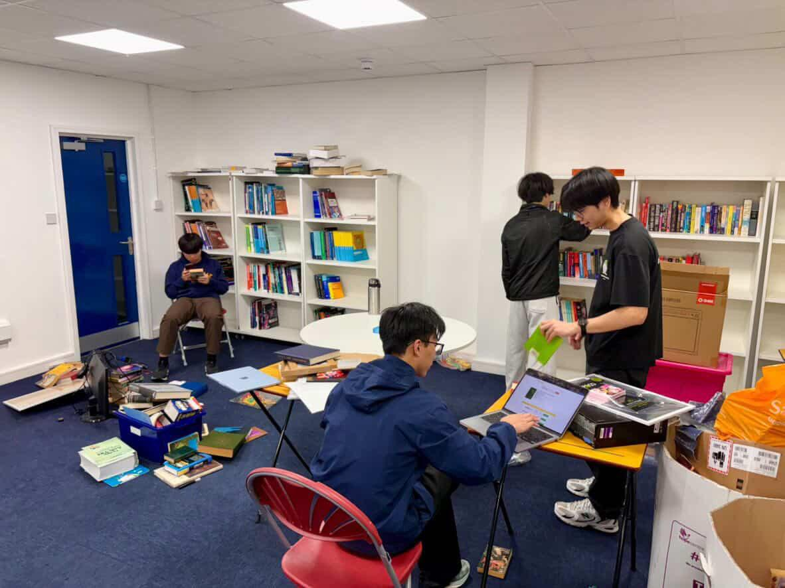
Step 3: Build the website and integrate the databases into the website
At the same time, my friend was building the skeleton of the website. After I finish adding the data into the database, I wrote SQL queries the website. We worked together, giving feedback and editing the design of the website and the functions.

Step 4: Testing and Evaluation
The library is now at the testing and evaluation phase. It is nearly done and will be released for students’ use after the half-term break. We also asked our friends to test it beforehand, and the feedback was good. There were some comments about the UI/UX of the website, and we are fixing them.

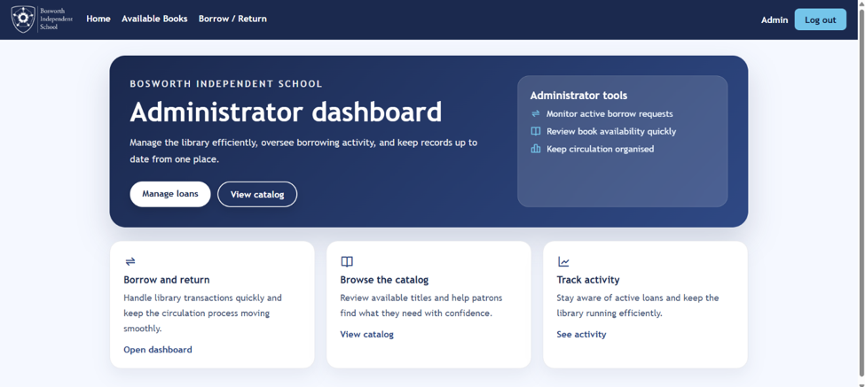

- [USER INPUT NEEDED - Development Note (1–2 câu)]:
  - Việc số hóa thư viện này giúp ích gì cho học sinh trong trường và đã học được gì khi tự thiết kế cấu trúc cơ sở dữ liệu kết hợp với giao diện web?
Digitalizing the process and refurbishing the library connects students with the library, creating a quiet and relaxed space. More students went to the library during break and lunch time for a nap or popped in to borrow a book.

For myself, after doing the project, I knew how to take data from real life, build a database from there, and integrate into a website.
- [DEV / UI INSTRUCTION - Media Slot 4]:
  - Ảnh chụp giao diện tìm kiếm/mượn sách của Web App + Sơ đồ bảng Database

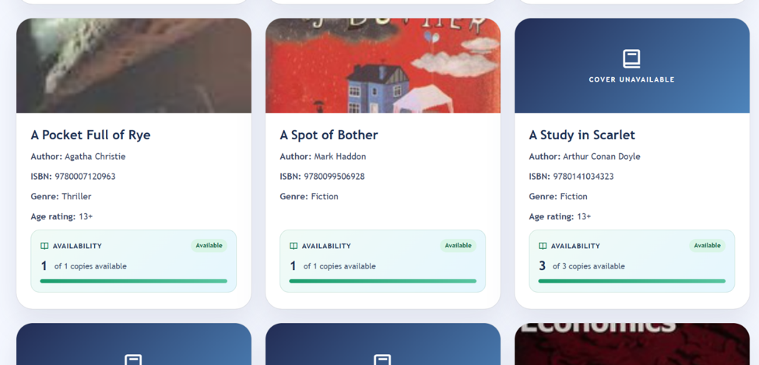
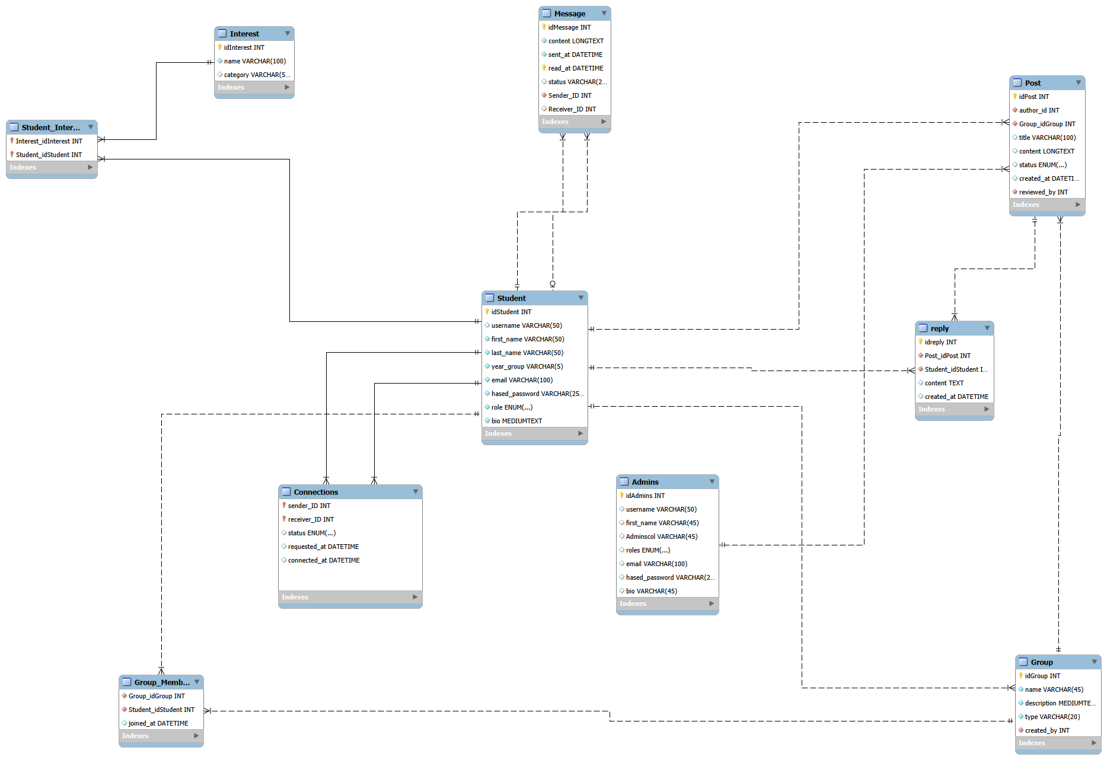

4. VENTURE & LEADERSHIP EXPERIENCE SECTION
- [DEV / UI INSTRUCTION]: Featured Spotlight Card at the top for "FlexAid" (Entrepreneurship Spike), followed by a 2-column grid for UK Campus Leadership and Vietnam Tournament Leadership.
- [STATIC COPY - Section Header]:
  - Eyebrow: 03 / ENTREPRENEURSHIP & COMMUNITY IMPACT
  - Heading (H2): Venture Creation & Leadership

4.1. Featured Venture Spotlight: "FlexAid" (CATS Global Schools Business Incubator, UK)
- [STATIC COPY]:
  - Award Badge: 1st Place Winner: CATS UK Business Incubator Competition (2026)
  - Role: "FlexAid" Team Leader | Location: Northampton, UK | Timeline: Oct 2025 – Apr 2026
  - Overview:
    - Architected a soft-wrap knee brace integrated with sensors and an adaptive air-bag system to protect joints during activity.
    - Led a cross-functional team in market research, financial modeling, and go-to-market strategy.
- [USER INPUT NEEDED - (2-3 câu)]:
  - Ý tưởng làm nẹp gối tích hợp cảm biến và túi khí thích ứng xuất phát từ quan sát nào (có liên quan đến niềm đam mê đá bóng/thể thao không?)? Khoảnh khắc nào khi dẫn dắt nhóm làm tài chính và thuyết trình giúp em giành Giải nhất CATS UK?
- [DEV / UI INSTRUCTION - Media Slot]:
  - Embed slide deck (hoặc 3 ảnh chụp bản vẽ thiết kế sản phẩm + mô hình tài chính) và ảnh nhận giải Nhất.

4.2. Leadership Grid (Left: UK | Right: Vietnam)
- [STATIC COPY - Column 1: Bosworth Independent School (Northampton, UK)]:
  - Vice House Captain (Delapré House) (Jan 2026 - Present)
    - Execute inter-house STEM and sports competitions proposed by the student body, driving participation across the house with 44 players and 100+ spectators.
    - Collaborate directly with the Director of Student Development, senior faculty, and Head Students to enhance academic and residential life.
    - Serve as the primary liaison between the student community and school leadership.
  - Member, Charity & Environment Committee (Student Council) (Sept 2025 - Present)
    - Conducted empirical audits on school dining food waste through staff and chef interviews, launching a school-wide waste-reduction awareness campaign.
    - Delivered a climate-action presentation to the entire school community on Earth Day 2026 and organized a tree-planting event with more than 40 participants.
    - Organized a student-led food-sale fundraiser, raising £200+ for the charity FoodKind.
  - Community Bike Workshop & Events Volunteer: Delapré Abbey Preservation Trust (Mar 2026 - June 2026)
    - Provided hands-on technical assistance and customer support at a weekend community bicycle repair workshop for a registered local charity.
    - Collected and structured large-scale customer datasets, building an organized inventory and tracking database table for store operations.
    - Supported core operational teams during major public charity events.
- [STATIC COPY - Column 2: CSP Sporting Federation (Hanoi, Vietnam)]:
  - General Leader | CSP Challenger 2024 (CC24 Badminton and Table Tennis Tournament) (Sept 2023 - June 2025)
    - One of the largest badminton and table tennis tournaments in Cau Giay district.
    - Supervised an organizing committee of 30+ members to deliver a city-wide tournament for 120+ high school athletes.
    - Directed marketing operations, produced promotional video trailers, and supported public relations outreach, increasing reach and impressions by nearly 300%.
  - Head of Communications | Gifted Students Cup 2024 (GSC24 Football Tournament) (Sept 2023- June 2025)
    - Strategized and executed the multi-channel promotional campaign, coordinating across departments to increase social media reach by 245% and impressions by 279%.
    - Trained and mentored volunteer content creators; negotiated co-marketing partnerships and media sponsorships with partner schools and local press.

5. MEDIA CONTENT & LIVE BROADCASTING SECTION
- [DEV / UI INSTRUCTION]: Must clearly separate the two distinct media entities: "Huấn Luyện Viên Online" (Content Production & Community Management) and "Huấn Luyện Viên Onlive" (Live Broadcasting & Tactical Streaming). Include two embedded YouTube players side-by-side under the second channel.
- [STATIC COPY - Section Header]:
  - Eyebrow: 04 / DIGITAL MEDIA & PUBLIC SPEAKING
  - Heading (H2): Sports Tactical Analysis & Live Broadcasting

5.1. Channel 1: “Huấn Luyện Viên Online” YouTube Channel
- [STATIC COPY]:
  - Role: Media Content Creator | Location: Hanoi, Vietnam | Timeline: Sept 2023 – Nov 2024
  - Key Achievements (From CV):
    - Managed a football analysis Facebook page with 50,000+ followers, authoring weekly tactical and post-match analyses, averaging 300 engagements/post with 5 posts reaching more than 1,000 engagements.
    - Scripted and edited short-form videos for a TikTok channel reaching 40,000+ followers and 1,000,000+ total likes, averaging 20,000 views/video.
    - Coordinated social media product promotions, handled customer inquiries, and organized both online and offline community viewing events.

5.2. Channel 2: “Huấn Luyện Viên Onlive” YouTube Channel
- [STATIC COPY]:
  - Role: Streamer & Technical Support | Location: Hanoi, Vietnam | Timeline: June 2024 – Nov 2024
  - Key Achievements (From CV):
    - Hosted live streams on YouTube during match-days, delivering pre- and post-match tactical analysis.
    - Interacted with live chat in real-time, answered audience questions, and collaborated with the media content team.
- [DEV / UI INSTRUCTION - Embedded Video Players]:
  - Embed two responsive YouTube iframe players with custom titles and viewer badges:
    - Video Embed 1: Euro 2024 Discussion Stream (4.9K viewers): URL: https://www.youtube.com/watch?v=HCPhCWWSRH8&t=922s
    - Video Embed 2: Pre-Semifinal Analysis Stream (2K viewers): URL: https://www.youtube.com/watch?v=myTIuRhE6DA&t=2722s
- [USER INPUT NEEDED - Reflections on Broadcasting (1–2 câu)]:
  - Việc phân tích chiến thuật trực tiếp cho hàng nghìn người xem và xử lý bình luận thời gian thực trên Huấn Luyện Viên Onlive đã rèn luyện sự tự tin và khả năng truyền tải thông tin phức tạp như thế nào?

6. EDUCATION, HONORS & SKILLS
- [DEV / UI INSTRUCTION]: Clean 3-column architectural table or tabbed bento layout for rapid scanning by admissions officers.
- [STATIC COPY - Section Header]:
  - Eyebrow: 05 / ACADEMIC CREDENTIALS & TOOLKIT
  - Heading (H2): Education, Honors & Technical Skills

6.1. Education & External Courses
- [STATIC COPY]:
  - Bosworth Independent School, Northampton, UK (Sept 2025 - Present)
    - A-Level Candidate (Year 13) | Predicted Grades: A*A*A*A* (Maths, Further Maths, Computer Science, Physics)
    - Standardized Testing: SAT: 1540 (Math: 790, RW: 750) | IELTS Academic: 8.0
  - High School for Gifted Students, Hanoi National University of Education, Vietnam (Sept 2023 - May 2025)
    - GPA: Grade 10: 9.7/10 | Grade 11: 9.6/10
  - Nguyen Tat Thanh Lower and Upper Secondary School, Hanoi, Vietnam (Sept 2019 - May 2023)
    - GPA: Grade 9: 9.6/10
  - External Courses & Technical Self-Study:
    - Siemens Certification: Siemens Engineering Work Experience
    - University of Liverpool Certification: Virtual Summer School (Designing for Impossibilities)
    - Technical Self-Study: Currently reading Fundamentals of Electrical Engineering by Giorgio Rizzoni (Fundamentals of Electric Circuits)

6.2. Honors & Awards
- [STATIC COPY]:
  - Gold Medal: 50th International Invention Show: INOVA (2026)
  - Frank Dickens Scholarship (Full-Tuition Award): Bosworth Independent School (2025-2027)
  - 1st Prize Winner: CATS UK Business Incubator Competition (2026)
  - Gold Certificate: UKMT Senior Mathematical Challenge (SMC) (2025)
  - Bronze Medal: UKMT Andrew Jobbings Senior Kangaroo (Invite-only national round) (2025)
  - Nguyen Tat Thanh Merit Scholarship: Awarded for 4 consecutive terms (2021-2023)
  - 2x Silver & 1x Bronze Medalist: School Football Tournaments (GC23, SC24, SC25: Greeting Cup & Spring Cup)

6.3. Skills & Interests
- [STATIC COPY]:
  - Hard Skills: Python, SQL, C/C++; Electronic Component Assembly; Circuit Design & Prototyping.
  - Soft Skills: Leadership; Systems Thinking; Public Speaking; Cross-functional Collaboration.
  - Interests & Affiliations: Sports (Football, Basketball, Billiards, Chess – Member of the Ams Chess Academy and the Wisdom Hub of Youth); Fashion; Movies; Playing Guitar and Singing.

7. FOOTER & CONTACT SECTION
- [DEV / UI INSTRUCTION]: Minimalist dark footer with direct email copy-to-clipboard button, social links, and a downloadable Resume button.
- [USER INPUT NEEDED - Closing Call-to-Action Note]:
  - Viết 1-2 câu lời chào kết trang (Ví dụ: đang hướng tới kỳ tuyển sinh đại học ngành EEE và rất mong được kết nối với các giáo sư, hội đồng tuyển sinh hoặc những người cùng đam mê chế tạo phần cứng)
If anyone passing by has an interest in connecting to me for future projects on electrical or electronic, I would love to receive emails from you guys!
- [STATIC COPY - Links]:
  - Email: [Your Email Address]
  - Location: Northampton, UK | Hanoi, Vietnam
  - Links: LinkedIn | GitHub | Download Resume (PDF)

